CE214 Engineering Mechanics STATICS
Section 001, Summer Session 1, 2024
10:00 – 11:30, M to F
2213 Engineering Building 3 and Distance Ed

Instructor: Dr. David W. Parish
416, 111 Lampe Dr. Bldg
email: dwparish@ncsu.edu
phone: 919 515-3263

Office Hours: MTWTH 12:00-1:00; There may be occasions, however, when I cannot keep these office hours (meetings, conferences, etc.) I will try to keep you as fully informed as possible. You are welcome to drop by any time my office door is open. Please feel free to call or send email, especially if you think your question requires only a brief answer or explanation. If you call and I am not in, please leave a voice mail message.

Teaching Asst.: To be announced

Prerequisites: A grade of C- or better in MA 241 and PY 205; MA 242 is a corequisite. These pre- and corequisites will be strictly enforced. It may take some time to check these prerequisites for all currently on the roll. Therefore, you may be dropped after the last day to add, so if you have not satisfied the pre- and corequisites, please drop the course now.

Text: Engineering Mechanics STATICS by R.C. Hibbler @2022
15th edition, Published by Pearson Prentice Hall. Previous editions of the same book cannot be used. This book is available as hardback or electronically via the “All-In” Program. Refer to information sheet posted in moodle. Cost through NC State bookstore is $103.75 for e-text and access to mastering engineering. Those that purchase the e-text and access can also obtain a loose leaf copy of the book for an additonal $53.25 which can be extremely helpful.

All students in your class will have free access to the digital books until May 17. Students wanting to get the All In materials at the lowest price must place their order for the books before May 17.
Purchase Link:
The link below will take students directly to the textbooks for your class where they can then place an order for the All In books if they choose to take advantage of the lower-cost digital textbook option. You can add this to your Moodle page as well to help students get the correct books for your class.
https://shop.ncsu.edu/AI-ENGINEERING-MECHANICS-STATICS?quantity=1&ccid=88829&itemid=77134

Objectives: This course is fundamental to several subsequent courses in engineering including CE225 and/or MAE 214. A grade of C- or better is required in CE 214 to take these following courses. By the end of the course you will be able to:

1. Draw free-body diagrams
2. Formulate and solve the equations of equilibrium
3. Determine internal forces for simple structures
4. Draw shear force and bending moment diagrams for beams
5. Determine friction forces and their effects on rigid bodies
6. Determine the centroid, center of gravity, and moment of inertia

Grading: Homework 10%
Mid Term Exam 1 25%
Mid Term Exam 2 25%
Final Exam 40%

Grading System: 97-100 A+ 93-96.9 A 90-92.9 A-
87-89.9 B+ 83-86.9 B 80-82.9 B-
77-79.9 C+ 73-76.9 C 70-72.9 C-
67-69.9 D+ 63-66.9 D 60-62.9 D-
<60 F

Homework: Homework will be assigned in each class and will be due at the beginning of the next class. Late homework will not be accepted; however, the lowest three homework grades will be dropped before determining the final course grade. Approximately 3 or 4 problems will be assigned each class. One or more homework problems will be selected for detailed grading. Homework will be returned in a timely manner. Homework solutions will be posted on the website. Format for the homework is enclosed. To receive full credit for homework, the following standards must be followed: Use high quality paper, preferably scaled engineering paper, and write on only one side of each sheet. No pen and ink will be accepted. Multiple page submissions must be stapled. All papers must be flat. Solutions must be neat and orderly, free body diagrams and other required sketches must be complete and accurate, and all numerical results must have the proper units.
Group work on homework is encouraged; however, each student must prepare his or her own work for submission.

Distance students will send homework in via email or text as provided by our distance-ed services. Work will be returned in a timely manner.

Tests The mid-terms and the final exam will be comprehensive closed book/no notes. A study guide will be provided. Formulas will be provided when necessary. Problems will be similar to, but not identical to, homework and examples worked out in the text and in class. Approximately one-third of the problems on each test will be graded based upon the final answer only, i.e., there will be no partial credit if the final answer is wrong or if the units are either missing or incorrect. These problems will be short and based on very basic concepts. The other part of the exam will have partial credit. A make-up final will be given under only the most extraordinary circumstances, and require written request and documentation.

No make-up test will be given for Test 1 and/or Test 2. Instead, the percentage of these tests will be rolled forward into the percentage of the final exam provided that the test is missed due to an excused absence with submitted documentation. Therefore, if you miss one test, your final exam is worth 75% of your grade. If you miss both tests, your final exam is worth 90% of your grade in the class.

Attendance: Full participation in classes and examinations is expected of all students. Homework submissions may be used to verify attendance. Do not turn in homework for others in the class.

Important
Dates: 1. Wed, May 15, 1st day of class
2. Thur, May 16, Last day to add without permission
or change from credit to audit or credit only.
3. Fri, May 17, Census Day
4. Mon, May 27, Memorial Day (university closed)
5. Mon, Jun 3, Drop/Revision Deadline
6. Tue, Jun 18, Last day of classes
7. Wed, Jun 19, Junteenth Observed (no classes)
8. Thur, Jun 20 Final Exam 8:30 -11:00 AM

Additional Reasonable accommodations will be made for students with verifiable
Information disabilities. In order to take advantage of available accommodations, students
must register with Disability Services for Students at 1900 Student Health Center, Campus Box 7509, phone 515-7653
http://www.ncsu.edu/provost/offices/affirm_action/dss/

Student shall adhere to the University policy on academic integrity found in the Code of Student Conduct, found from the University website. By signing each homework assignment and exam, the student attests to the following University Honor Pledge: “I have not either given nor received unauthorized aid on this test or assignment.” Any actions against this honor pledge will be punished to the extent allowed by the University.

Study Suggestions

- Study textbook and lecture notes for each and every lecture
- Start studying as soon after class as possible, and seek help as needed.
- Study worked-out examples in the textbook and in the lecture notes
- Work on these problems, with solutions covered up, and then compare with the
solutions. This can be very beneficial in assessing and correcting your
understanding of the material.
- ONLY AFTER you complete the above steps, start the homework. Check your
work using alternative solution methods whenever available. Check your work with a classmate; check the answer in the back of the book.
- You should plan on spending at least 2-3 hours outside the class for each hour of
lecture. But start early and seek help as needed from the TA or me.

Course Outlines:

Chapter or Activity | Topic | Approx. number of classes and overlap
1 | Introduction; General Principles | 1
2 | Force Vectors | 3
3 | Equilibrium of a Particle | 3
4 | Force System Resultants | 4
5 | Equilibrium of a Rigid Body | 7
6 | Structural Analysis | 6
7 | Internal Forces/ Fluids | 7
8 | Friction | 3
9 | Center of Gravity and Centroid | 3
10 | Moment of Inertia | 3
Exams |  | 2
Reviews |  | 2

Homework Requirements

A professional format is required to obtain a grade on homework.

- Homework will be prepared on engineering paper only. Use only one side of the paper.

- Name, course and section (row), homework set number, date, and paging appear from left to right at the top of each sheet (see sample).

- Problem number is the upper left corner under the heading.

- “GIVEN:” or the problem statement follows the number and this statement will contain the essence of what is given in data and information. A machine copy of the problem is not required.

- Sketch (es) or drawing(s) of the system or structure to be considered will follow the problem statement. The sketch must contain all dimensions, other physical parameters, and the coordinate system that will be used.

- What is required to be found from the problem or “FIND:” is the next section after the sketch. All parts requested are sequentially listed in this section.

- The problem “SOLUTION:” will then follow, and it will be arranged in a neat, logical and orderly fashion.

- The answers will be underlined or boxed with units given and, if appropriate, a sense of direction. Negative signs should not be used when an arrow is used to show direction. All work must be written in pencil or typed and a system of ‘vertical alignment’ should be used to make the work easier to follow and giving the work a professional appearance. Solutions must be neat and detailed with all the relevant diagrams, sign conventions, etc. No pen and ink will be accepted.

- All straight lines are made with a straight edge or by a ‘very careful hand’ so it appears to be drawn with an edge.

- All problem sets will have the individual pages stapled together in the upper hand corner and the papers will not be folded. Homework with no staples will get 2 points deducted.

- Submit all pages flat, not folded.

As a rule, late homework assignments will not be accepted. For exceptions, written proof of unavoidable circumstances is required. When possible, prior permission for exceptions to the policy should be requested.
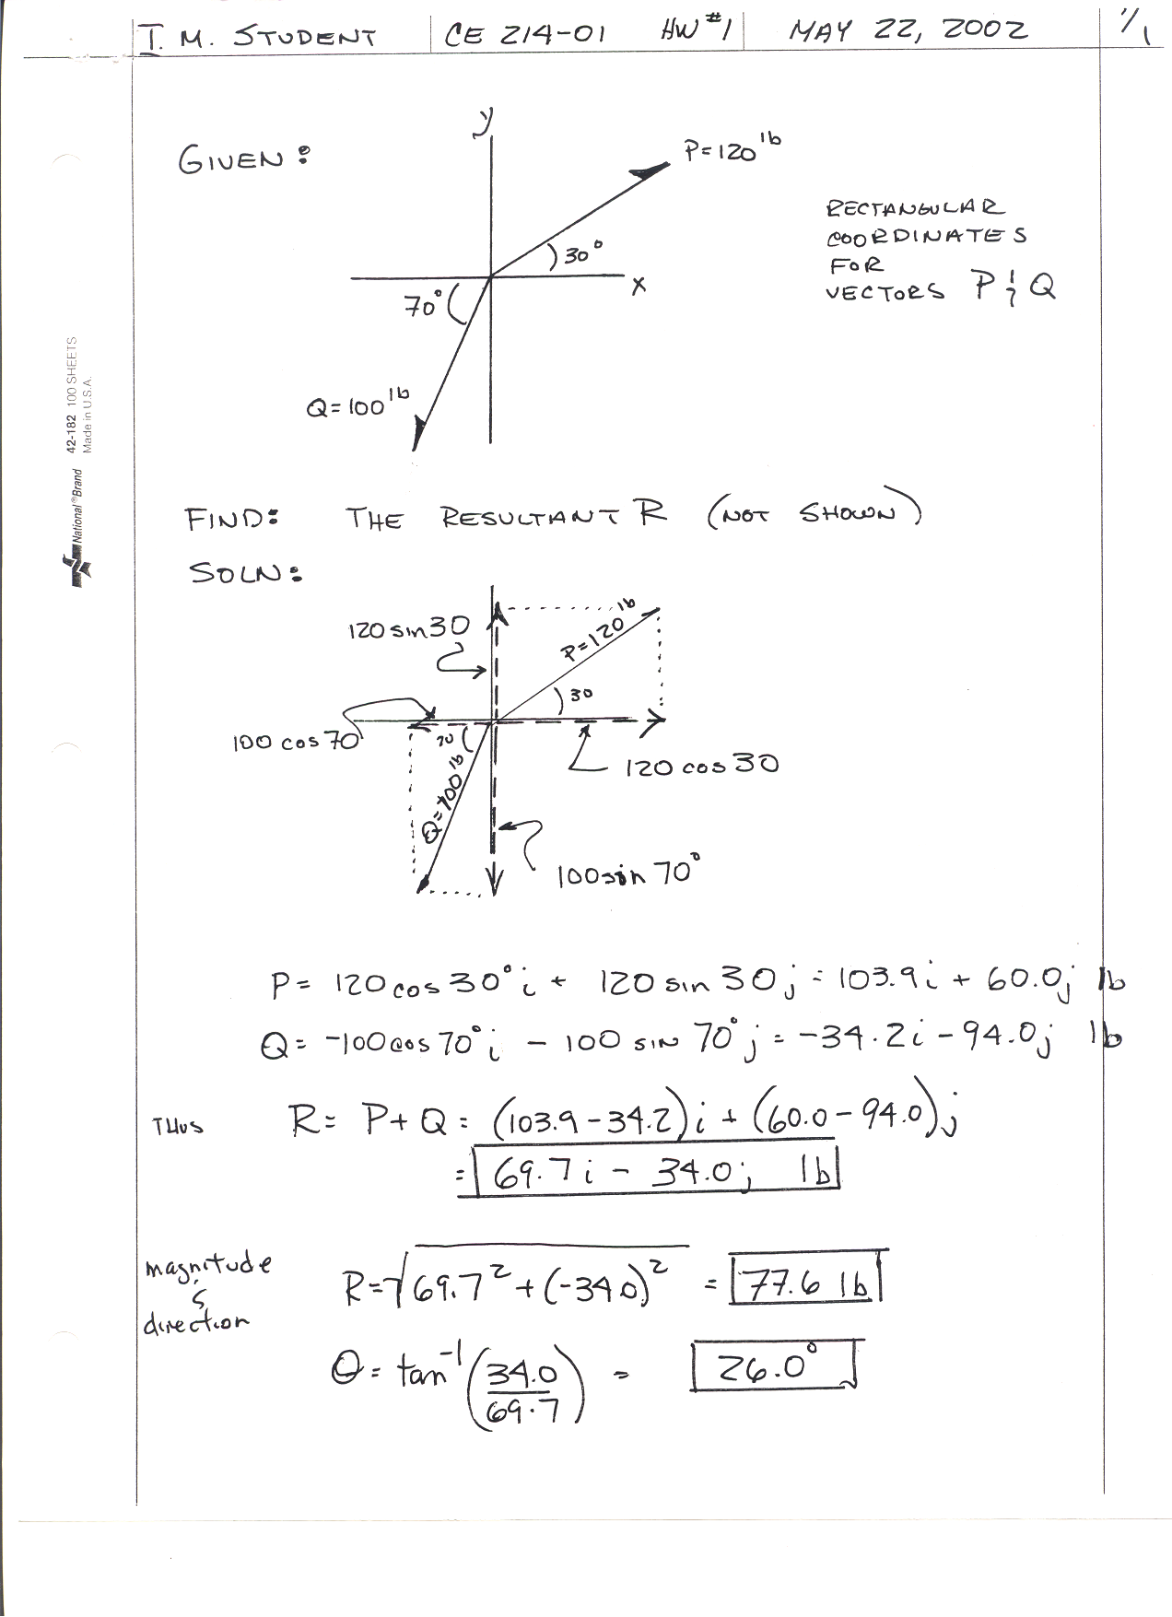

Table of lecture topics and homework assignments

Date | Topic/ Sections in text | Homework problems
5-15 | Introduction, Chapter 1
5-15 | Force Vectors, Chapter 2
5-16 | Force Vectors, Chapter 2
5-16 | Force Vectors, Chapter 2
5-20 | Equil. of Particles, Chapter 3
5-20 | Equil. of Particles, Chapter 3
5-22 | Equil. of Particles, Chapter 3
5-22 | Force Sys. Res., Chapter 4
5-23 | Force Sys. Res., Chapter 4
5-24 | Force Sys. Res., Chapter 4
5-23 | Equil. of Rigid Body, Chapter 5
5-23 | Equil. of Rigid Body, Chapter 5
5-24 | Equil. of Rigid Body, Chapter 5
5-24 | Equil. of Rigid Body, Chapter 5
5-27 | MEMORIAL DAY HOLIDAY
5-28 | Equil. of Rigid Body, Chapter 5
5-29 | Review for Exam 1
5-30 | EXAM 1
5-31 | Plane Truss, Method of joints, Chapter 6
5-31 | Method of joints; Chapter 6
6-3 | Method of joints; Chapter 6
6-3 | Method of sections, Chapter 6
6-3 | Method of sections, Chapter 6
6-4 | Method of sections, Chapter 6
6-4 | Frames and machines , Chapter 6
6-4 | Frames and machines , Chapter 6
6-5 | Internal forces (V and M), Chapter 7
6-6 | Internal forces (V and M), Chapter 7
6-6 | Internal forces (V and M), Chapter 7
6-7 | Internal forces (V and M), Chapter 7
6-7 | Internal forces (V and M), Chapter 7
6-10 | Internal forces (V and M), Chapter 7
6-10 | Internal forces (V and M), Chapter 7
6-11 | Centroid of planar bodies, Chapter 9
6-11 | Review for Exam 2
6-12 | EXAM 2
6-13 | Centroid of composite bodies, Chapter 9
6-13 | Centroid of composite bodies, Chapter 9
6-14 | Moments of inertia, Chapter 10
6-14 | Moments of inertia, Chapter 10
6-17 | Moments of inertia, Chapter 10
6-17 | Dry friction, Chapter 8
6-17 | Dry friction, Chapter 8
6-18 | Dry friction, Chapter 8
6-18 | Last Day of Classes Review for Final
6-19 | HOLIDAY (Juneteenth)
6-20 | FINAL EXAM - THURSDAY 8:30-11:00

Review of Mathematics

1. Quadratic Equation: 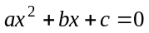, solutions: 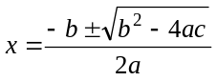

2. Determinants: 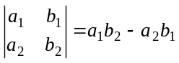, 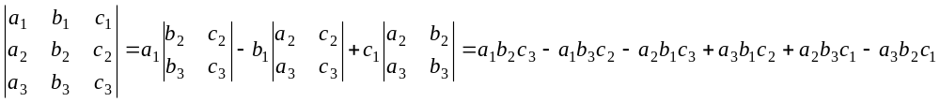

3. Trigonometry:

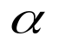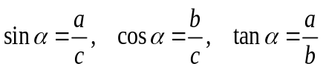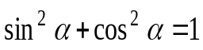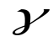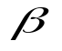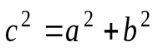
b
a
c
a
b
c
Law of sines:
Law of cosines:

4. Derivatives:

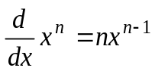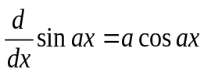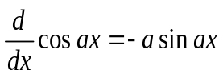
5. Integrals:
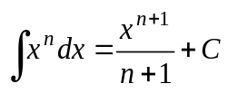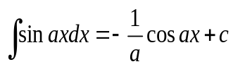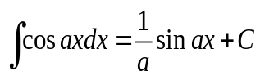

6. Geometry:

a
b
Area = ab
b
h
Area =
b
h
h
a
b
Area =
r
Area =

7. Vectors:

a. Given,
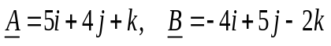
where, i, j and k are unit vectors along x, y and z coordinates.

Determine, 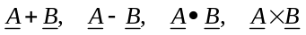

b.
x
y
30º
100 mm
O
A

If, i and j are the unit vectors along x and y axes respectively, write the Cartesian vector expression of the vector OA.

Find the unit vector along OA.

c. A Cartesian vector is given as 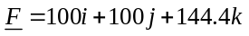. Determine the magnitude of the vector F.

